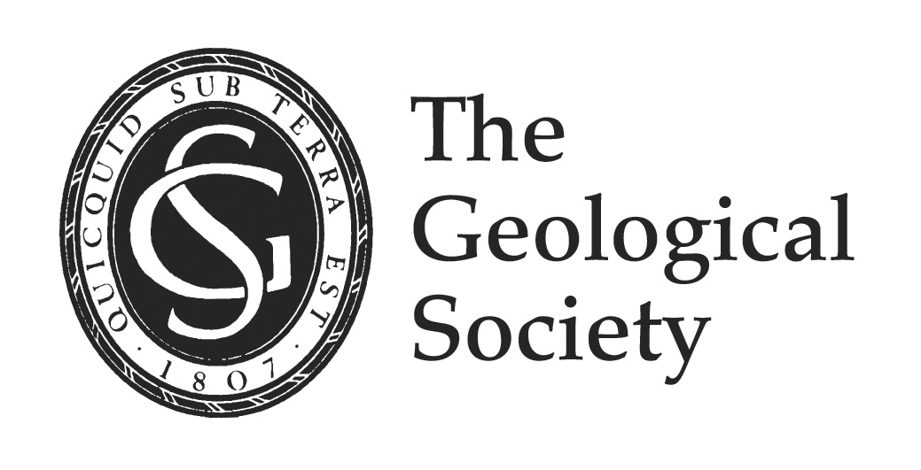

Awards Ceremony 2016 – senior medallists’ talks

Lyell Medal
(John Underhill – Chair of Exploration Geoscience, Institute of Petroleum Engineering, Heriot-Watt University)

The need for and increasing role of forensic geosciences and visualisation in accurately characterising the subsurface

[abstract to follow]

Murchison Medal
(Jon Blundy – Professorial Research Fellow in Petrology, University of Bristol)

The mute testimony of volcanic crystals and what we can learn about the build up to eruptions
The crystals in igneous rocks, both volcanic and plutonic, are invariably zoned, with plagioclase feldspar being the most notable example. It has long been recognised that the zoning patterns tell us something about the processes that led to the formation of the rock in which the crystal is found. But what, exactly? Physical perturbation of magmatic system? Insights into the timescales of magma system evolution? Clues to precursory activity at restless volcanoes? In this short presentation I will show how recent advances in microbeam analysis, understanding of mineral chemistry and thermodynamics, numerical modelling, and high-temperature experiments are enabling us to unlock the testimony of zoned volcanic crystals. I will provide some examples of the remarkable stories they have to tell, with examples from Mount St. Helens, Bezymianny and Uturuncu volcanoes.

William Smith Medal
(Michael de Freitas – Distinguished Research Fellow, Faculty of Engineering, Department of Civil and Environmental Engineering, Imperial College)

A Homage to William Smith: aspects of recent research
For the purposes of this meeting three aspects of recent research have been chosen that I hope William Smith would find closely allied to his own interests; viz. the structure and eventual mapping of the London Basin, the behaviour of old clay slopes and the description of soil and rock. The surprise for London has been the way so much information from quite different sources has at last started to come together to reveal a pattern of pull-apart structures concealed by Quaternary sediments. The surprise for slopes, of the sort Smith would be familiar through his work with canals on “side-long ground”, is the apparent maturity of their movement to that of stratified viscous laminar flow. As for the descriptions of soil and rock, here the surprise is in how well these materials can describe themselves; Smith allowed the materials to define themselves for the sequences he used and much of great value to science and engineering resulted. The same approach, when applied at microscopic and nanoscopic scales, also yields remarkable results of considerable commercial potential to science and engineering.

Wollaston Medal
(Susan Brantley – Distinguished Professor of Geosciences, Pennsylvania State University)

Exploring the Critical Zone: Where Rocks Meet life
We have probed the moon and the bottom of the ocean but many aspects of the life-sustaining layer of soil, rock, and water beneath our feet remain to be explored. This layer, known as the critical zone, is now the target of study for critical zone scientists worldwide who are investigating all aspects of the layer from vegetation canopy to bedrock. In the critical zone, soils are formed, water is filtered, ecosystems are nurtured, and landscapes are sculpted. Two questions central to critical zone science will be addressed: Why are soils present on a planet with robust mountain-building and erosion? How deep can we fracture rock to exploit hydrocarbons without jeopardizing the water resources we need for future generations?

